Assignment-15
Lab 15 – Backend API Development: Creating RESTful Services with AI

Task 1 – Student Records API Task:
Use AI to build a RESTful API for managing student records.
Instructions:
• Endpoints required:
o GET /students → List all students o POST /students → Add a new student o PUT /students/{id} → Update student details o DELETE /students/{id} → Delete a student record
- Use an in-memory data structure (list or dictionary) to store records.
- Ensure API responses are in JSON format. Code :
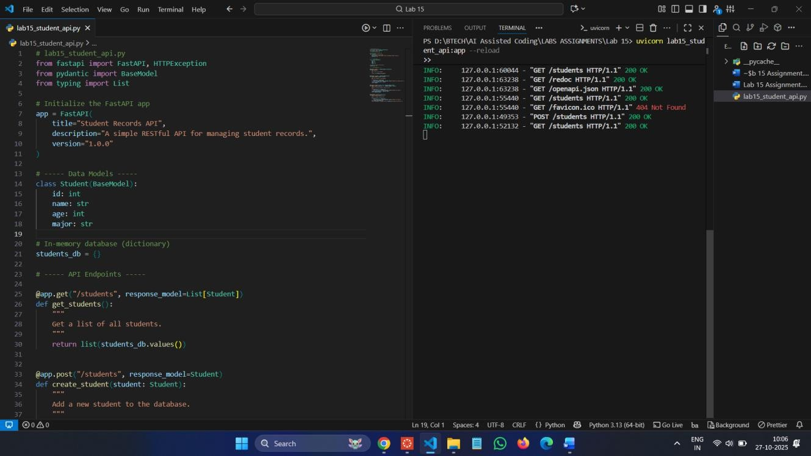
Swagger UI: http://127.0.0.1:8000/docs

Commands :
pip install fastapiuvicorn
uvicorn lab15_student_api:app –reload Output:
POST :
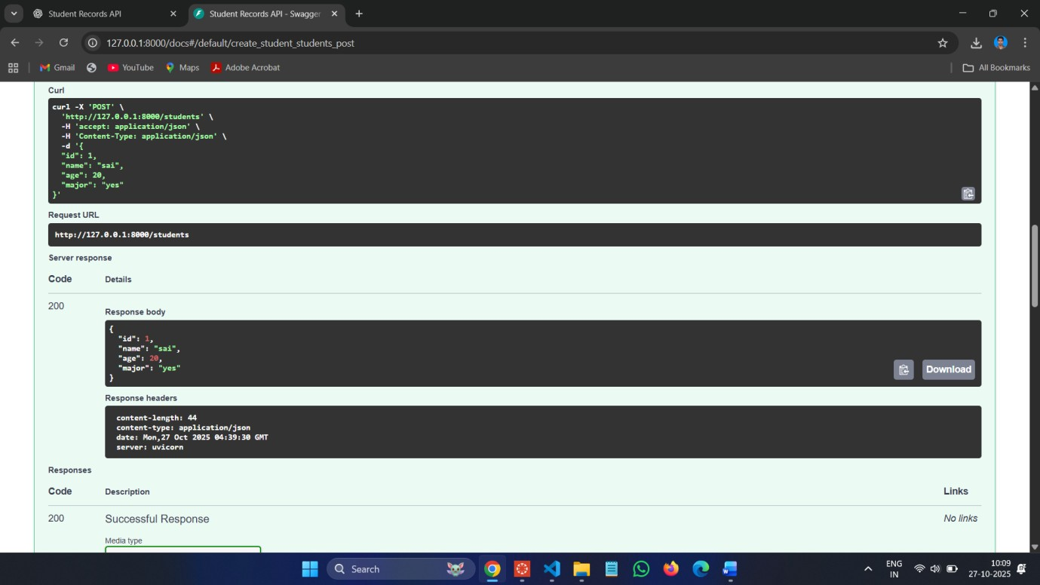

GET :
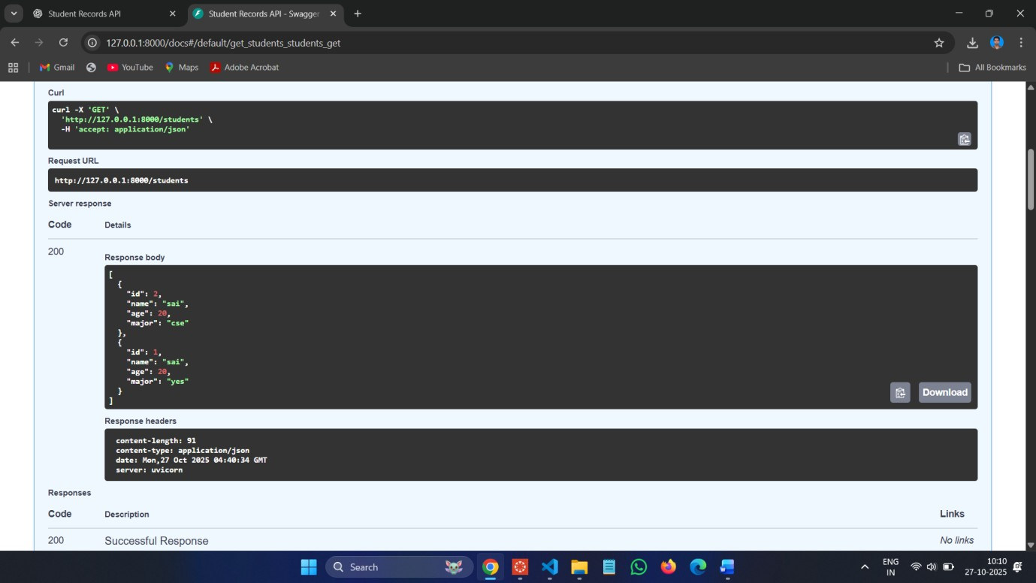

PUT :
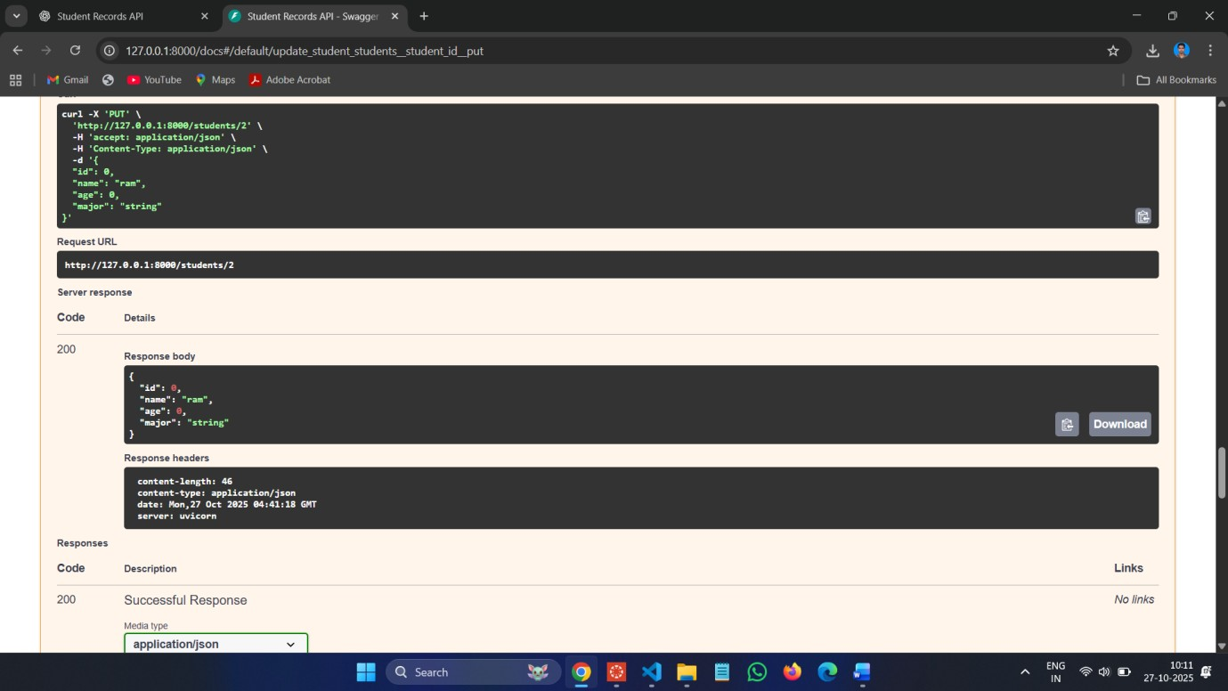
DELETE :
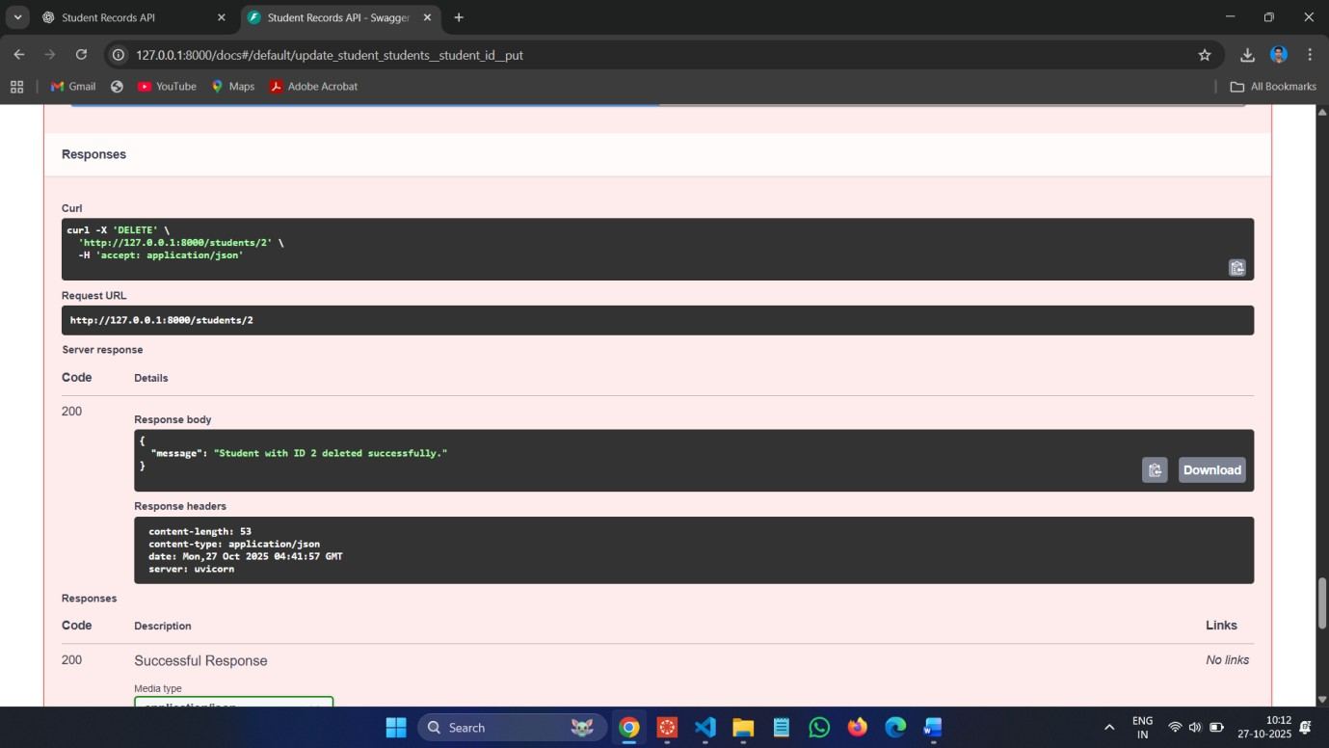

Task 2 – Library Book Management API Task:
Develop a RESTful API to handle library books.
Instructions:
• Endpoints required:
- GET /books → Retrieve all books o POST /books → Add a new book
- GET /books/{id} → Get details of a specific book o PATCH /books/{id} → Update partial book details (e.g., availability)
- DELETE /books/{id} → Remove a book
• Implement error handling for invalid requests.

Code :
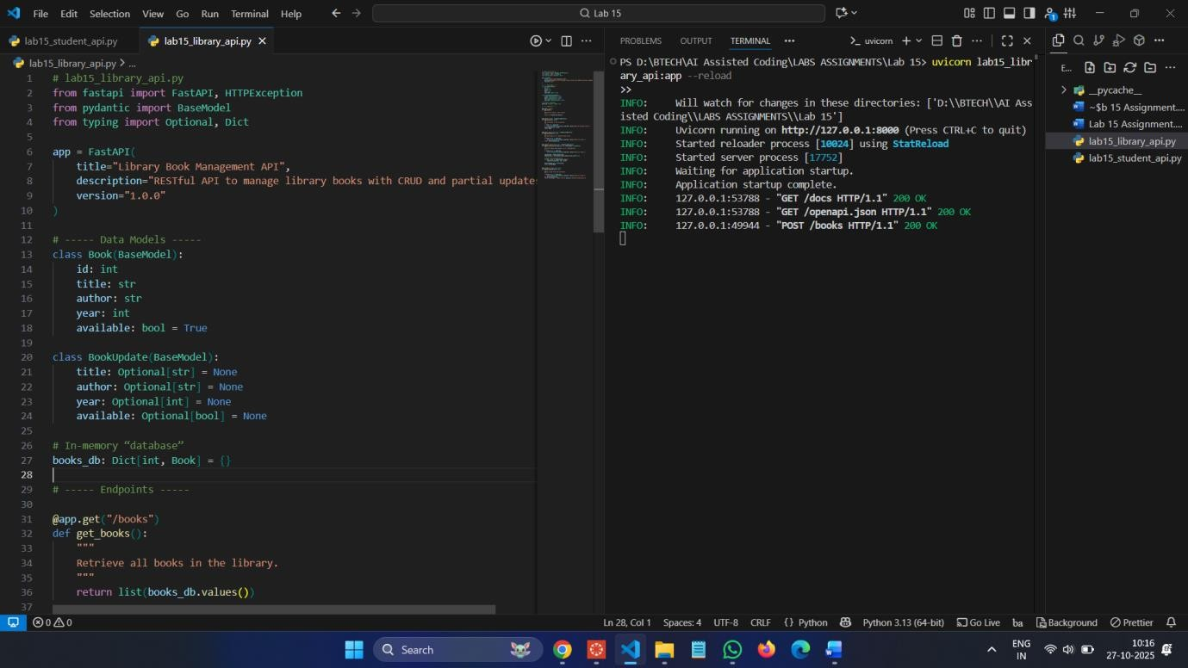
Commands :
uvicorn lab15_library_api:app –reload Swagger UI:http://127.0.0.1:8000/docs POST :
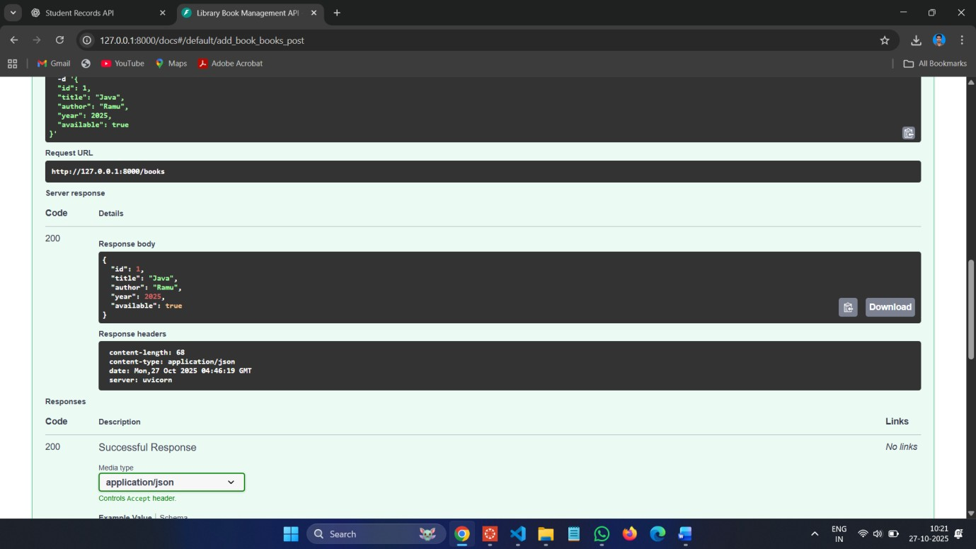
GET :
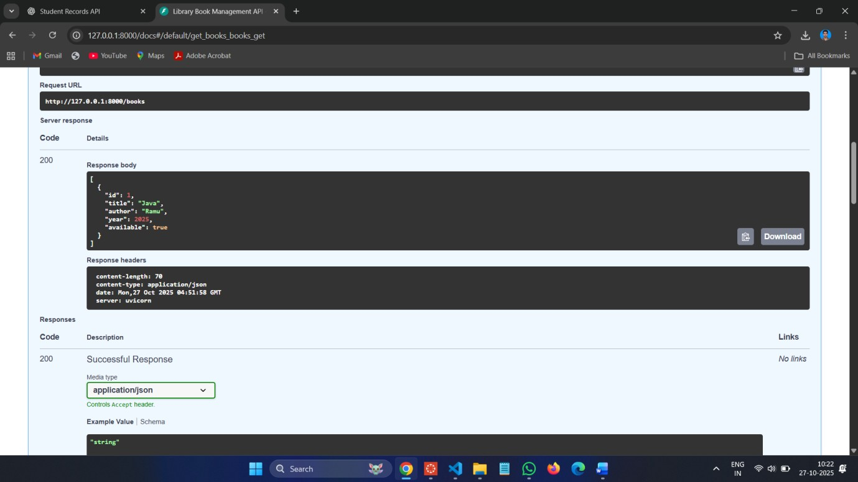

PUT :
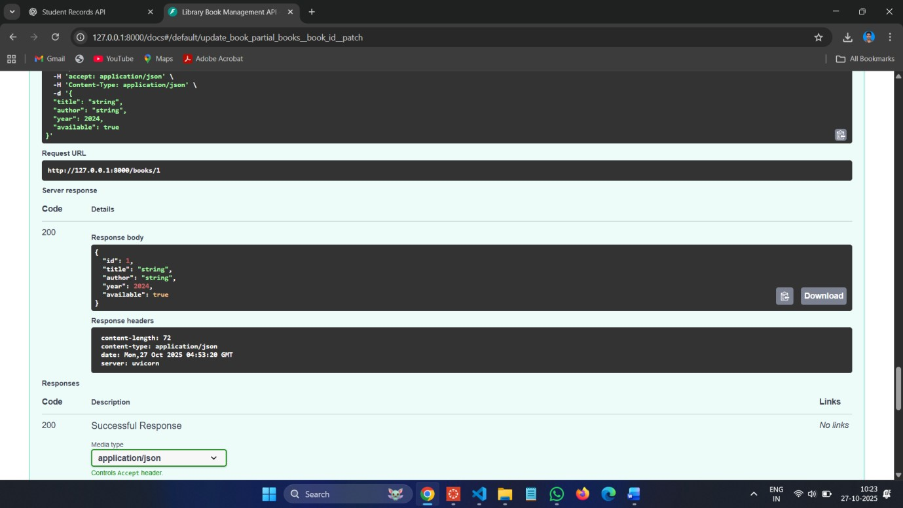
DELETE :
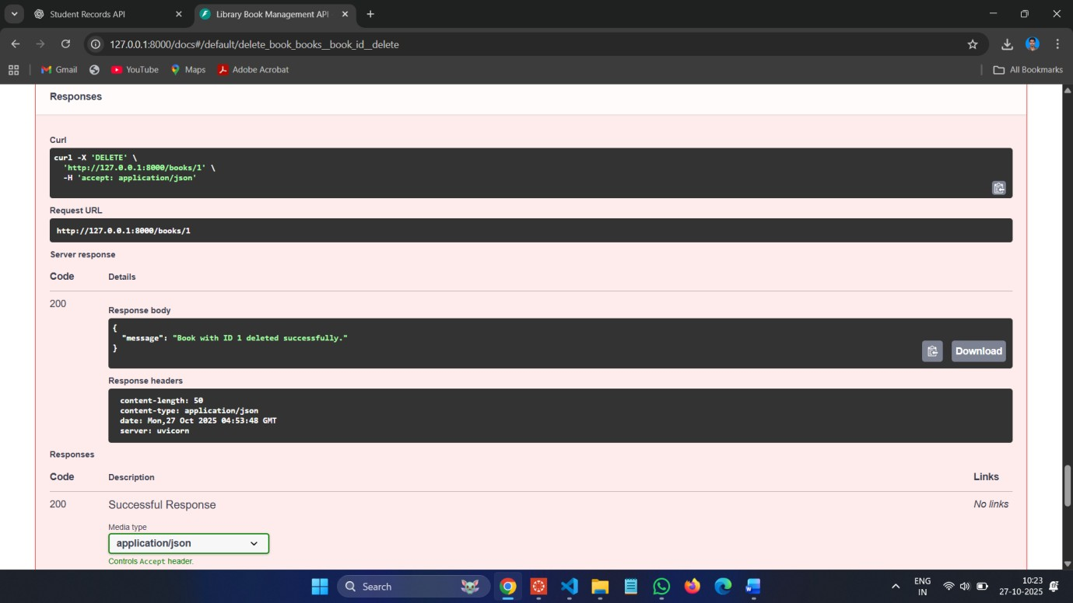

Task 3 – Employee Payroll API Task:
Create an API for managing employees and their salaries.
Instructions:
• Endpoints required:
- GET /employees → List all employees
- POST /employees → Add a new employee with salary details
- PUT /employees/{id}/salary → Update salary of an employee
- DELETE /employees/{id} → Remove employee from system
• Use AI to:
- Suggest data model structure.
- Add comments/docstrings for all endpoints. Code :
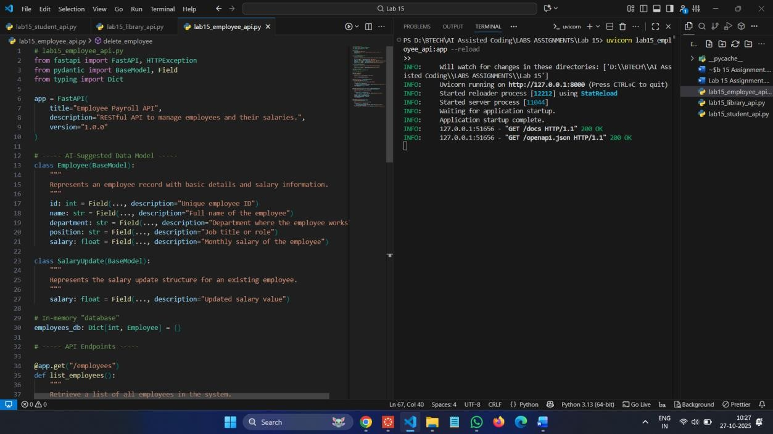
Commands :
uvicorn lab15_employee_api:app –reload
Swagger UI: http://127.0.0.1:8000/docs POST :
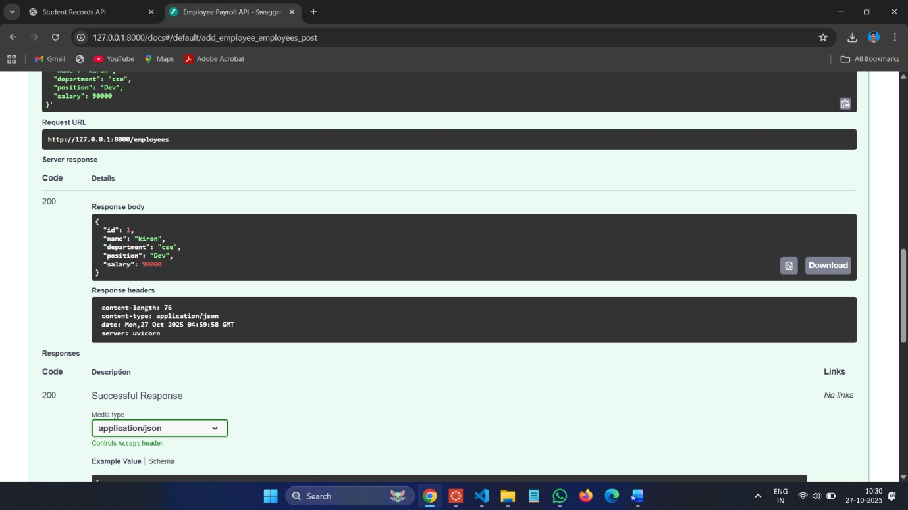
GET :
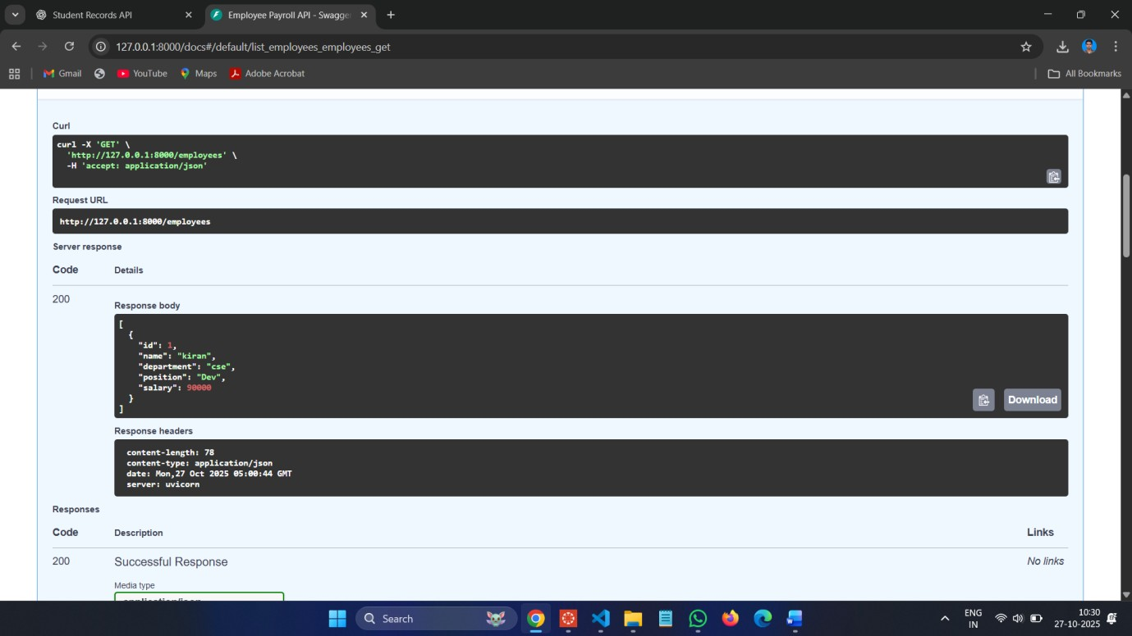

PUT :
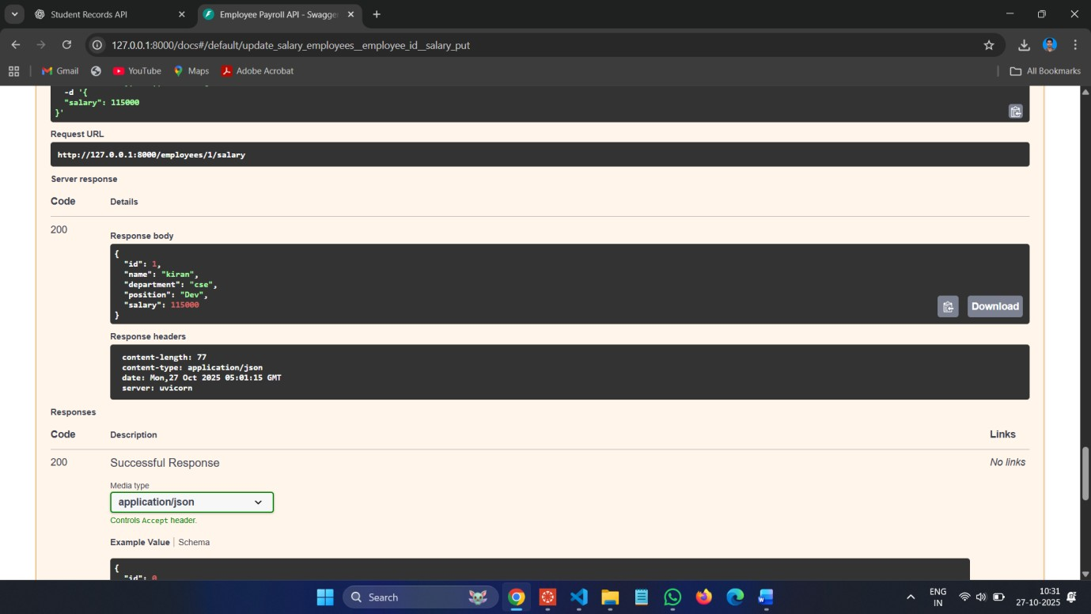
DELETE :
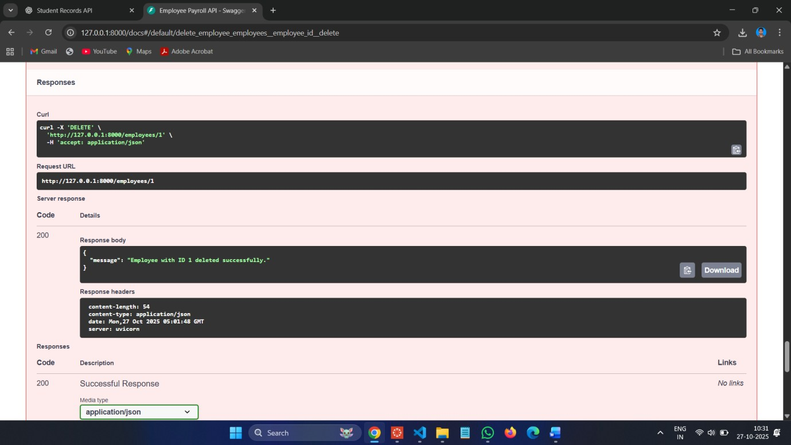

Task 4 – Real-Time Application: Online Food Ordering API Scenario:
Design a simple API for an online food ordering system.
Requirements:
• Endpoints required:
- GET /menu → List available dishes o POST /order → Place a new order o GET /order/{id} → Track order status o PUT /order/{id} → Update an existing order (e.g., change items) o DELETE /order/{id} → Cancel an order • AI should generate:
- REST API code
- Suggested improvements (like authentication, pagination) Code :
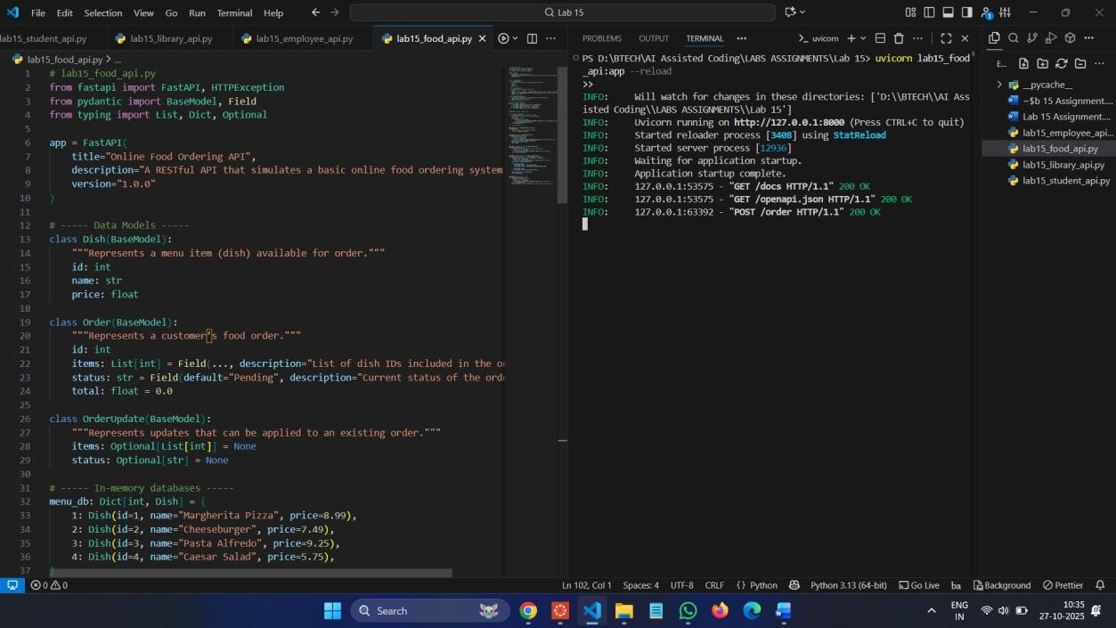
Commands :
uvicorn lab15_food_api:app --reload
Swagger UI: http://127.0.0.1:8000/docs
POST :
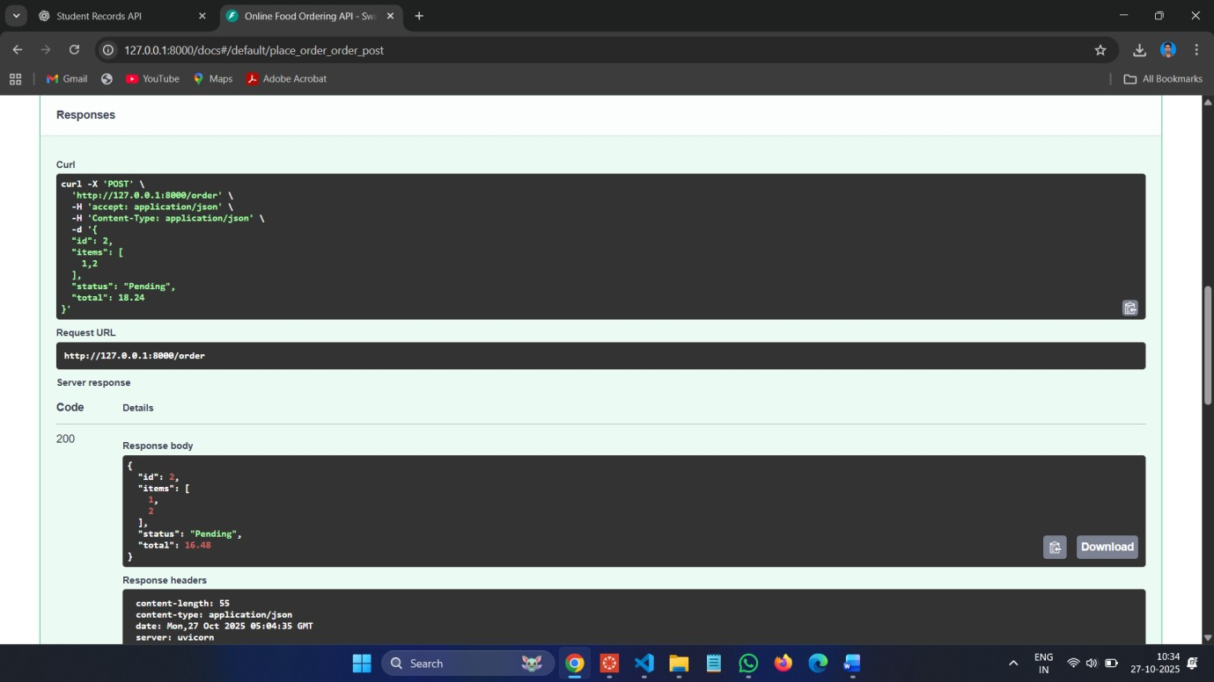
GET :
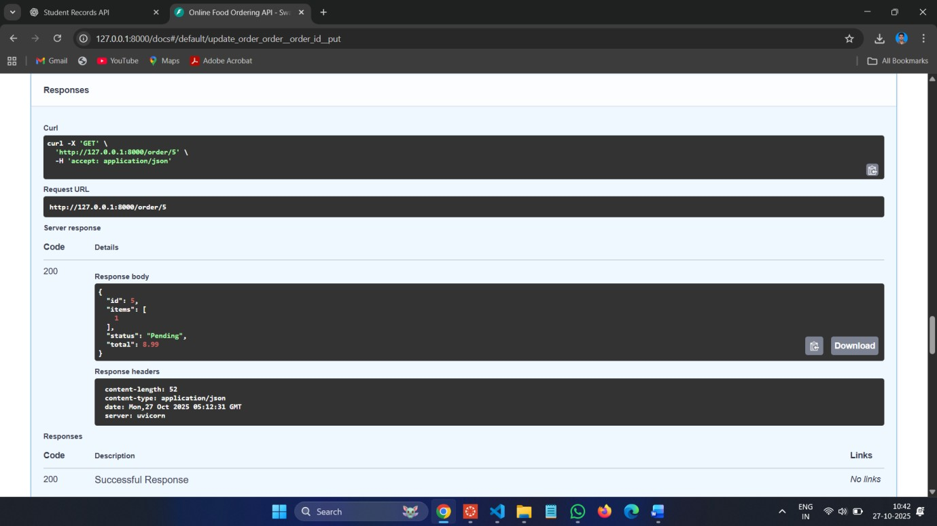

PUT :
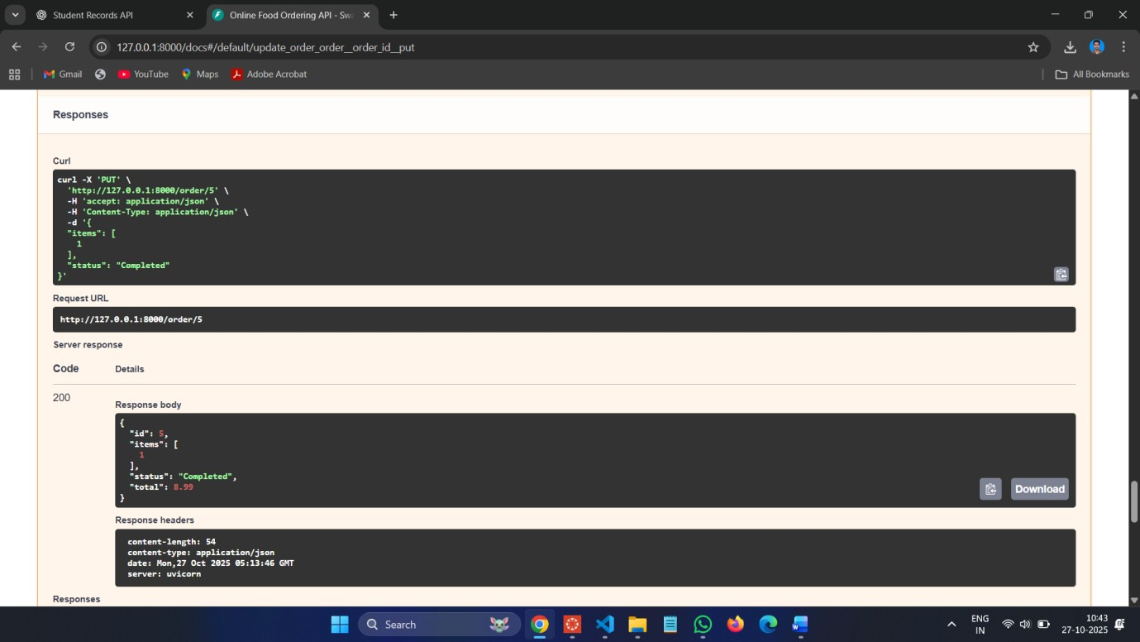
DELETE :
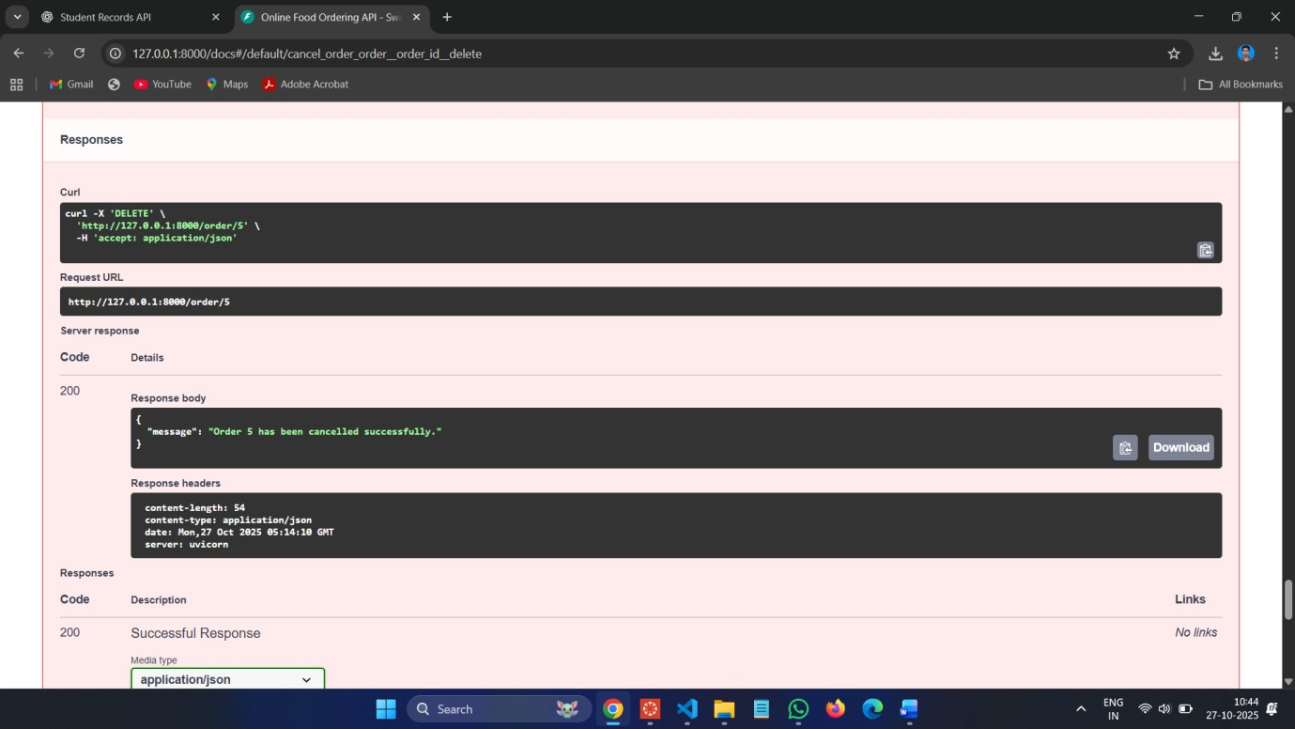

Observations:
  - RESTful Design Principles:
Each task followed REST standards — using appropriate HTTP methods (GET, POST, PUT, PATCH, DELETE) and clear URL structures for resources like /students, /books, /employees, and /order.
  - AI-Assisted Code Generation:
AI tools were effectively used to generate data models, endpoint structures, and documentation automatically, saving development time and ensuring consistency.
  - CRUD Operations:
All four APIs successfully implemented CRUD functionality:
- Create: POST requests o Read: GET requests o Update: PUT/PATCH requests o Delete: DELETE requests
- Error Handling:
Each API handled invalid requests gracefully using HTTPException with proper status codes and messages.
- Auto Documentation:
FastAPI automatically provided API documentation through /docs (Swagger UI) and /redoc (ReDoc), fulfilling the lab’s documentation objective.
- Partial Updates & Real-Time Design:
  - Task 2 introduced partial updates (PATCH) for library books.
  - Task 4 simulated a real-world food ordering system with realistic order tracking and AI improvement suggestions.
- AI-Driven Improvements:
Suggested features such as authentication, pagination, realtime updates (via WebSockets), and database integration demonstrate how AI can enhance backend architecture planning.

